EXP NO : 08 **NMAP TO DISCOVER LIVE HOSTS**

DATE: 10.09.2024

AIM:

To use Nmap to discovery live hosts using ARP Scan ,ICMP scan , and TCP/UDP Ping Scan in the tryhackme platform.

TASK : 2 - SUBNETWORKS:

Send a packet with following

1. From computer1
2. To computer1 ( to indicate it is broadcast )

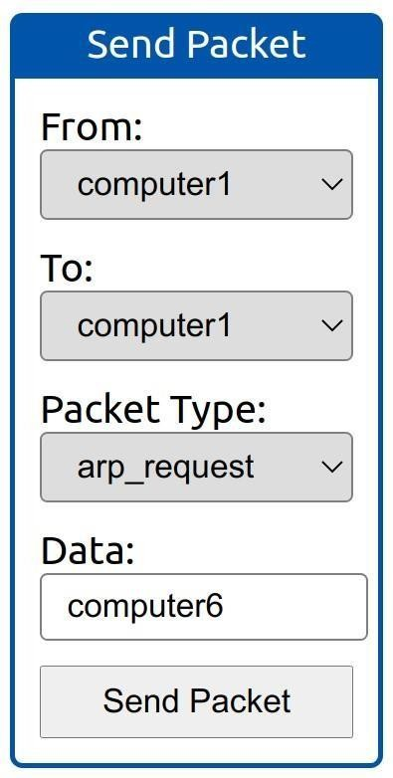



1. From computer1
2. To computer1 ( to indicate it is bro
3. From Computers
4. To computer1(to dicate it is broadcast)
5. Packet Type: “ ARP Request”
6. Data : computer6 ( because we are asking for computer6 MAC address using ARP Request )

How many devices can see the ARP Request? Ans : 4

Did computer6 receive the ARP Request ? ( Y / N ) Ans : N Send a packet with the following:

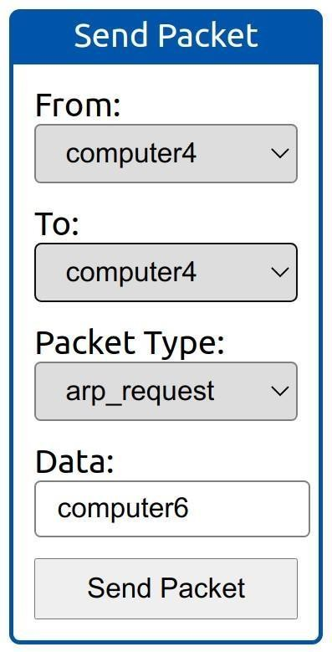



* 1. From computer4
  2. To computer4 ( to indicate it is broadcast )
  3. Packet Type: “ ARP Request”
  4. Data : computer6 ( because we are asking for computer6 MAC address using ARP Request )

How many devices can asee the ARP Request ? Ans : 4

Did computer6 reply to the ARP Request ? (Y / N ) Ans : Y TASK - 3 : Enumerating Targets

What is the first IP address Nmap would scan if you provided 10.10.12.13/29 as your target ? Ans : 10.10.12.8

How many IP addresses will Nmap scan if you provide the following range 10.10.0-255.101-125 ?

Ans : 6400

TASK - 4 : Discovering Live Hosts Send a packet with following :

1. From computer1
2. To computer3
3. Packeet Type : “Ping Request”

What is the type of packet that computer1 sent before the ping ? Ans : ARP Resquest

How many computers responded to the ping request? Ans : 1 Send a packet with following:

1. From computer2
2. To computer5
3. Packet Type: “Ping Request”

What is the name of the first device that responded to the first ARP Request? Ans : router

What is the name of the first device that responded to the second ARP Request? Computer5 Send another Ping request.Did it required new ARP Requests? ( Y / N )

Ans : N

TASK - 5 : Nmap Host Discovery Using ARP

We will be sending broadcast ARP Requests packets with the following options:

* + From computer1
  + To computer1 (to indicate it is broadcast)
  + Packet Type: “ARP Request”
  + Data: try all the possible eight devices (other than computer1) in the network: computer2, computer3, computer4, computer5, computer6, switch1, switch2, and router.

How many devices are you able to discover using ARP requests? Ans : 3

TASK - 6 : Nmap Host Discovery Using ICMP Nmap Host Discovery Using ICMP :

What is the option required to tell Nmap to use ICMP Timestamp to discover live hosts? Ans : - PP

What is the option required to tell Nmap to use ICMP Address Mask to discover live hosts? Ans : -PM

What is the option required to tell Nmap to use ICMP Echo to discover live hosts? Ans : -PE

TASK - 7 : Nmap Host Discovery Using TCP and UDP

Which TCP ping scan does not require a privileged account? Ans : TCP SYN Ping

Which TCP ping scan requires a privileged account? Ans :

TCP ACK Ping

What option do you need to add to Nmap to run a TCP SYN ping scan on the telnet port? Ans : -PS23

TASK - 8 : Using Reverse - DNS Lookup

We want Nmap to issue a reverse DNS lookup for all the possibles hosts on a subnet, hoping to get some insights from the names. What option should we add? Ans : -R

RESULT :

Nmap to discover live host usng ARP scan ,ICMP scan and TCP/UDP ping scan in the tryhackme platform.